Experiment-4

Create a simple cloud software application for Library book reservation system for SIMATS library using any Cloud Service Provider to demonstrate Saas

Aim
To create a simple cloud-based Library Book Reservation System for the SIMATS Library using a Software as a Service (SaaS) platform to demonstrate online book reservation, member information management, and cloud-based data storage.

Procedure
- Log in to a cloud SaaS platform (such as Zoho Creator, Google AppSheet, or Salesforce).
- Create a new application named SIMATS Library Book Reservation System.
- Design a form with the following fields:
  - Student Name
  - Registration Number
  - Department
  - Email ID
  - Phone Number
  - Book Title
  - Book Author
  - Book ISBN
  - Reservation Date
  - Return Date
  - Book Availability (Available/Not Available)
- Add a Reserve Book button to confirm the reservation.
- Save the form and publish the application on the cloud.
- Enter the student and book details through the online form.
- Submit the reservation request.
- Verify that the reservation details are stored securely in the cloud database.
- View and manage reservation records from any device connected to the internet.

IMPLEMENTATION:

if(input.Reservation_Status == "Reserved")
{
days = input.Return_Date.daysBetween(input.Issue_Date);
input.Total_Amount = days * input.Charge_Per_Day;
}
else
{
input.Total_Amount = 0;
}

OUTPUT:

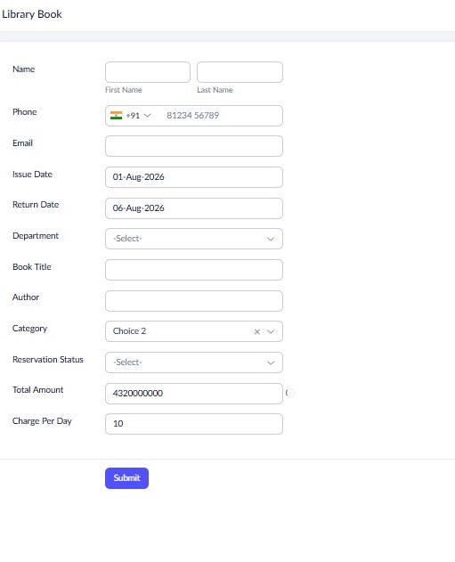

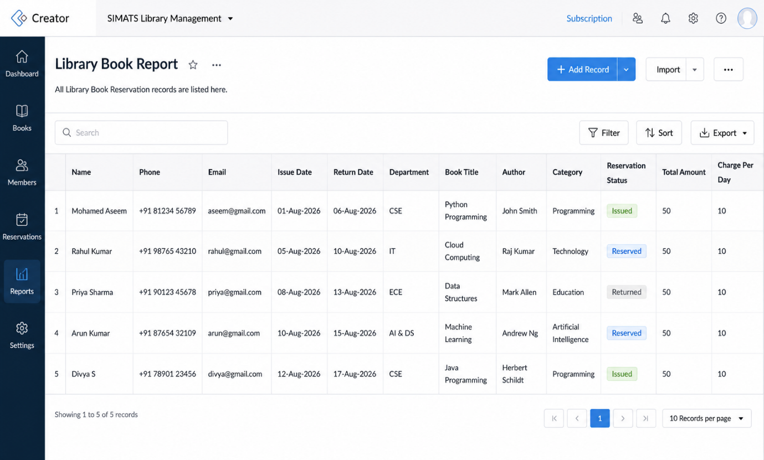

Result:
The Library Book Reservation System for the SIMATS Library was successfully developed and deployed using a Software as a Service (SaaS) cloud platform

